Introduction to Artificial Intelligence and Machine Learning (CSN12601)
ASSIGNMENT-1
Name : Aayansh Niranjan Date : 01/09/2025
Reg_No.: 20253004
Q1. Installation of Python and demonstration to run programming using Interpreter, IDLE,
Command Prompt, and Google Colaboratory.
INTERPRETER :
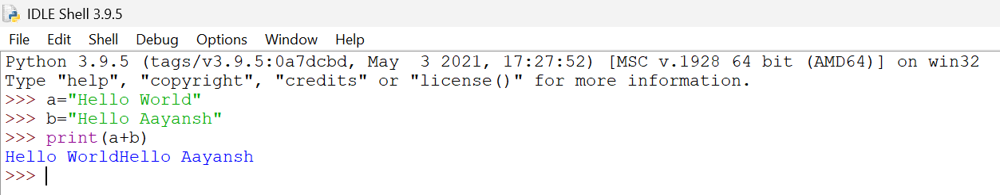
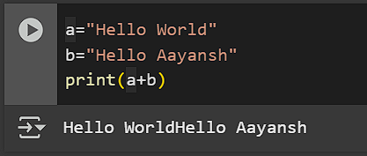
IDLE: GOOGLE COLAB:
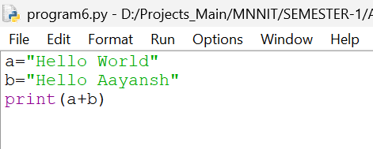

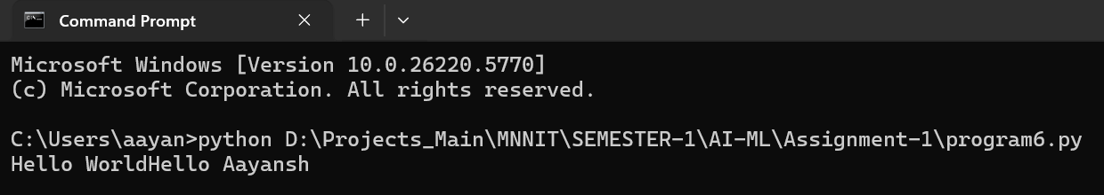
COMMAND PROMPT:

Q2. Write a program to demonstrate different number datatypes of python
A2. CODE : OUTPUT:
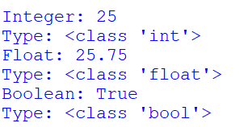
a=25
b=25.75
c=True
print("Integer:",a,"\nType:",type(a))
print("Float:",b,"\nType:",type(b))
print("Boolean:",c, "\nType:",type(c))

Q3. Python Programs to demonstrate of various Type Conversion Functions.
A3. CODE :
a = 10
b = 25.75
c = "50"
print("Integer:", a, "Type:", type(a))
print("Float:", b, "Type:", type(b))
print("String:", c, "Type:", type(c))
print()
print("Integer to float:", float(a),"Type:",type(float(a)))
print("Float to integer:", int(b),"Type:",type(int(b)))
print("Integer to string:", str(a),"Type:",type(str(a)))
print("String to integer:", int(c),"Type:",type(int(c)))

OUTPUT:
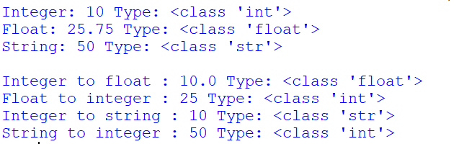

Q4. Write a program to perform different arithmetic operations on numbers in python.
A4. CODE:
a = 15
b = 4
print("First Number (a):", a)
print("Second Number (b):", b)
print()
print("Addition (a+b):",a+b)
print("Subtraction (a-b):",a-b)
print("Multiplication (a*b):",a*b)
print("Division (a/b):",a/b)
print("Modulus (a%b):",a%b)
print("Exponent (a**b):",a**b)
print("Floor Division (a//b):",a//b)

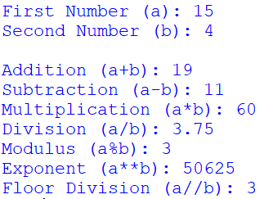
OUTPUT:

Q5. Write a program that include operators like "and", "or", "not" and Bitwise operators
- Bitwise and (&)
- Bitwise or (l)
- Bitwise ex-or (A)
- Bitwise complement (—)
- Bitwise left shift Operator (<<), and Bitwise right shift Operator
A5. CODE :
x = True
y = False
print("x AND y:",x and y)
print("x OR y:", x or y)
print("NOT x:", not x)
print()
a = 10
b = 4
print("Bitwise Operators:")
print("a=",a,"Binary:",bin(a))
print("b=",b,"Binary:",bin(b))
print()
print("a&b (Bitwise AND):",a&b,"Binary:",bin(a&b))
print("a|b (Bitwise OR):",a|b,"Binary:",bin(a|b))
print("a^b (Bitwise XOR):",a^b,"Binary:",bin(a^b))
print("~a (Bitwise NOT):",~a,"Binary:",bin(~a))
print("a<<1 (Left Shift):",a<<1,"Binary:",bin(a<<1))
print("a>>1 (Right Shift):",a>>1,"Binary:",bin(a>>1))

OUTPUT :
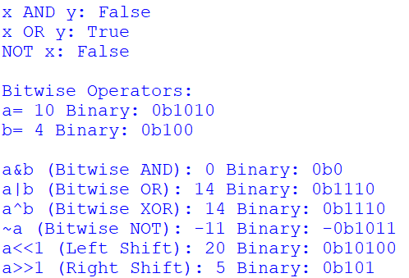

Q6. Write a program to create, concatenate and print a string and accessing substring from
a given string.
A6. CODE:
a="Introduction to"
b="Artificial Intelligence and Machine Learning"
print("Concatenation (a+b): ",a+b)
print("Printing : ",b)
print("String slicing : ",b[0:23])

OUTPUT:

